September 13, 2026 Name____________________

Family Legacies

Printed Text
Joshua 4:14 - 24 (KJV)

1. God used Moses to lead the Children of Israel out of Egypt by crossing
over the Red Sea. God used Joshua to lead the Children into the
Promised Land by crossing over the Jordan River.

In both events, the Children of Israel crossed over on d_____ l______.

Exodus 14:21 (KJV)
And Moses stretched out his hand over the sea;
and the LORD caused the sea to go back
by a strong east wind all that night,
and made the sea dry land, and the waters were divided.

Joshua 4:18 (KJV)
And it came to pass,
when the priests that bare the ark of the covenant
of the LORD were come up out of the midst of Jordan,
and the soles of the priests’ feet were lifted up unto the dry land,
that the waters of Jordan returned unto their place,
and flowed over all his banks, as they did before.

2. Give your estimate of the total number of people God led out of Egypt
through Moses.

___________________________

(#2 Scripture Reference next page.)
Exodus 12:37- 38 (KJV)
³⁷And the children of Israel journeyed from Rameses to Succoth,
about six hundred thousand on foot that were men, beside children. ³⁸ And a mixed
multitude went up also with them; and flocks, and herds, even very much cattle.

3. Complete each word blank in the box that indicates things that God provided
to the Children of Israel while they were in the wilderness.

W_______ God’s C________________ L _______

M_______ M______ P______ of W_________

S_______ S_______ B_______

Exodus 16:35 (KJV)
And the children of Israel did eat manna forty years, until they came to a land inhabited; they did eat manna, until they came unto the borders of the land of Canaan.

Exodus 33:10 (KJV)
And all the people saw the cloudy pillar stand at the tabernacle door: and all the people rose up and worshipped, every man in his tent door.

Exodus 13:21 (KJV)
And the LORD went before them by day in a pillar of a cloud, to lead them the way; and by night in a pillar of fire, to give them light; to go by day and night:

Deuteronomy 29:5 (KJV)
And I have led you forty years in the wilderness: your clothes are not waxen old upon you, and thy shoe is not waxen old upon thy foot.

Exodus 17:6 (KJV)
Behold, I will stand before thee there upon the rock in Horeb; and thou shalt smite the rock, and there shall come water out of it, that the people may drink. And Moses did so in the sight of the elders of Israel.

Numbers 11:31 (KJV)
And there went forth a wind from the LORD, and brought quails from the sea, and let them fall by the camp, as it were a day’s journey on this side, and as it were a day’s journey on the other side, round about the camp, and as it were two cubits high upon the face of the earth.

(#3 Scripture Reference next page.)
John 6:31 (KJV)
Our fathers did eat manna in the desert; as it is written, He gave them bread from heaven to eat.

Exodus 24:12 (KJV)
And the LORD said unto Moses, Come up to me into the mount, and be there: and I will give thee tables of stone, and a law, and commandments which I have written; that thou mayest teach them.

4. About 2 years after the Children of Israel crossed the Rea Sea, they came
within ten miles of the Promised Land. How many spies were sent out by Moses to survey the land?

1 2 3 4 5 6 7 8 9 10 11 12

Numbers 13:2 (KJV)
Send thou men, that they may search the land of Canaan, which I give unto the children of Israel: of every tribe of their fathers shall ye send a man, every one a ruler among them.

5. About 40 years after the Children of Israel crossed the Rea Sea, they came
within three miles of the Promised Land. How many spies were sent out by Joshua to survey the land?

1 2 3 4 5 6 7 8 9 10 11 12

Joshua 2:1 (KJV)
And Joshua the son of Nun sent out of Shittim two men to spy secretly, saying, Go view the land, even Jericho. And they went, and came into an harlot’s house, named Rahab, and lodged there.

6. On the attached map, underline Kadesh-barnea and circle the Canaan
Land . Is the Canaan Land (Promised Land) located on the

► northern side or southern side ► of Kadesh-barnea?

___________________________
(#6 Scripture Reference next page.)
Numbers 13:26 (KJV)
And they went and came to Moses, and to Aaron, and to all the congregation of the children of Israel, unto the wilderness of Paran, to Kadesh; and brought back word unto them, and unto all the congregation, and shewed them the fruit of the land.

7. The Children of Israel under Moses’ leadership were initially given the
opportunity to possess the Promised Land, but they refused this opportunity.

Give the percentage of the leaders of the Children of Israel
that you think refused this opportunity.

________%

Numbers 14:30 (KJV)
Doubtless ye shall not come into the land,
concerning which I sware to make you dwell therein,
save Caleb the son of Jephunneh, and Joshua the son of Nun.

8. When the Children of Israel finally reached the Jordan River to crossover and possess the land, Joshua ordered twelve stones to be placed on the other side of the Jordan River as a memorial of this event.

The twelve stones came from the __________________________________

_________________________________________________________

Joshua 4:8 (KJV)
And the children of Israel did so as Joshua commanded,
and took up twelve stones out of the midst of Jordan,
as the LORD spake unto Joshua,
according to the number of the tribes of the children of Israel,
and carried them over with them unto the place where they lodged,
and laid them down there.

9. Do you think the Children of Israel anticipated a war to possess the Promised
Land?

____________ Joshua 4:12 (KJV)
And the children of Reuben, and the children of Gad,
and half the tribe of Manasseh, passed over armed
before the children of Israel, as Moses spake unto them:
10. Why do you think the Children of Israel respected Joshua?

_______________________________________________________

_________________________________________________________

Joshua 4:14 (KJV)
On that day the LORD magnified Joshua in the sight of all Israel;
and they feared him, as they feared Moses, all the days of his life.

11. What did Joshua do when God told him to order the priests to bring the Ark of the Covenant up out of the Jordan River?

_________________________________________________________

Joshua 4:15 - 17 (KJV)
¹⁵ And the LORD spake unto Joshua, saying,
¹⁶ Command the priests that bear the ark of the testimony,
that they come up out of Jordan. ¹⁷ Joshua therefore commanded
the priests, saying, Come ye up out of Jordan.

12. What happened when the Ark of the Covenant came up out of the Jordan
River?

_______________________________________________________

_________________________________________________________

Joshua 4:18 (KJV)
And it came to pass, when the priests that bare
the ark of the covenant of the LORD were come up out of the midst of Jordan, and the soles of the priests’ feet were lifted up unto the dry land,
that the waters of Jordan returned unto their place,
and flowed over all his banks, as they did before.

13. The first month in the Jewish calendar corresponds to the month of

_________________ in our Western calendar.

January March - April July October December
(#13 Scripture Reference next page.)
Joshua 4:19 (KJV)
And the people came up out of Jordan on the tenth day of the first month,
and encamped in Gilgal, in the east border of Jericho.

14. The twelve stones that were taken out of the bottom of the dried up Jordan

River were placed in the city of ______________.

Gilgal

Jerusalem

Jericho

Joshua 4:20 (KJV)
And those twelve stones, which they took out of Jordan,
did Joshua pitch in Gilgal.

15. Circle the generation that you think will benefit most from the placing of

the twelve stones.

Past Generation

Present Generation

Future Generation

Joshua 4:21 - 22 (KJV)
²¹ And he spake unto the children of Israel, saying,
When your children shall ask their fathers in time to come,
saying, What mean these stones?
²² Then ye shall let your children know,
saying, Israel came over this Jordan on dry land.

16. The manner in which the Children of Israel crossed the Red Sea and the

Jordan River highlighted God’s ______________.

a. Provisions b. Peace c. Protection

(#16 Scripture Reference next page.)
Joshua 4:23 (KJV)
For the LORD your God dried up
the waters of Jordan from before you,
until ye were passed over, as the LORD your God did to the Red sea,
which he dried up from before us, until we were gone over:

17. Do you think the manner in which God led the Children of Israel across the Red Sea and the Jordan River sent a message to the world?

Yes or No

If Yes, what was the message to the world? ______________________

____________________________________________________

____________________________________________________

Joshua 4:24 (KJV)
That all the people of the earth
might know the hand of the LORD,
that it is mighty:
that ye might fear the LORD your God for ever.

Deacon Henry L. Goines, Th.D., Teacher brothergoines@aol.com
Adult Teacher, Higher Ground Fellowship Hour (225) 938-4230 (Text)
Mount Pilgrim Baptist Church

PRINTED TEXT

JOSHUA 4:14 - 24 (KJV)

¹⁴ On that day the LORD magnified Joshua in the sight of all Israel; and they feared him, as they feared Moses, all the days of his life.

¹⁵ And the LORD spake unto Joshua, saying,

¹⁶ Command the priests that bear the ark of the testimony, that they come up out of Jordan.

¹⁷ Joshua therefore commanded the priests, saying, Come ye up out of Jordan.

¹⁸ And it came to pass, when the priests that bare the ark of the covenant of the LORD were come up out of the midst of Jordan, and the soles of the priests’ feet were lifted up unto the dry land, that the waters of Jordan returned unto their place, and flowed over all his banks, as they did before.

¹⁹ And the people came up out of Jordan on the tenth day of the first month, and encamped in Gilgal, in the east border of Jericho.

²⁰ And those twelve stones, which they took out of Jordan, did Joshua pitch in Gilgal.

²¹ And he spake unto the children of Israel, saying, When your children shall ask their fathers in time to come, saying, What mean these stones?

²² Then ye shall let your children know, saying, Israel came over this Jordan on dry land.

²³ For the LORD your God dried up the waters of Jordan from before you, until ye were passed over, as the LORD your God did to the Red sea, which he dried up from before us, until we were gone over:

²⁴ That all the people of the earth might know the hand of the LORD, that it is mighty: that ye might fear the LORD your God for ever.

Reading Assignment

Joshua Chapter 11

I have read Joshua chapter 11.

My favorite verse is Joshua 11: ______

Student’s Full Name _________________________

Date ________________

Exegetical Comments on

Joshua 11: ______

_______________________________________________________

____________________________________________________________

____________________________________________________________

____________________________________________________________

____________________________________________________________

brothergoines@aol.com
(225) 938-4230 (Text)

Deacon Henry L. Goines, Th.D., Teacher
Adult Teacher, Higher Ground Fellowship Hour
Mount Pilgrim
The Children of Israel’s Journey
to the Promised Land

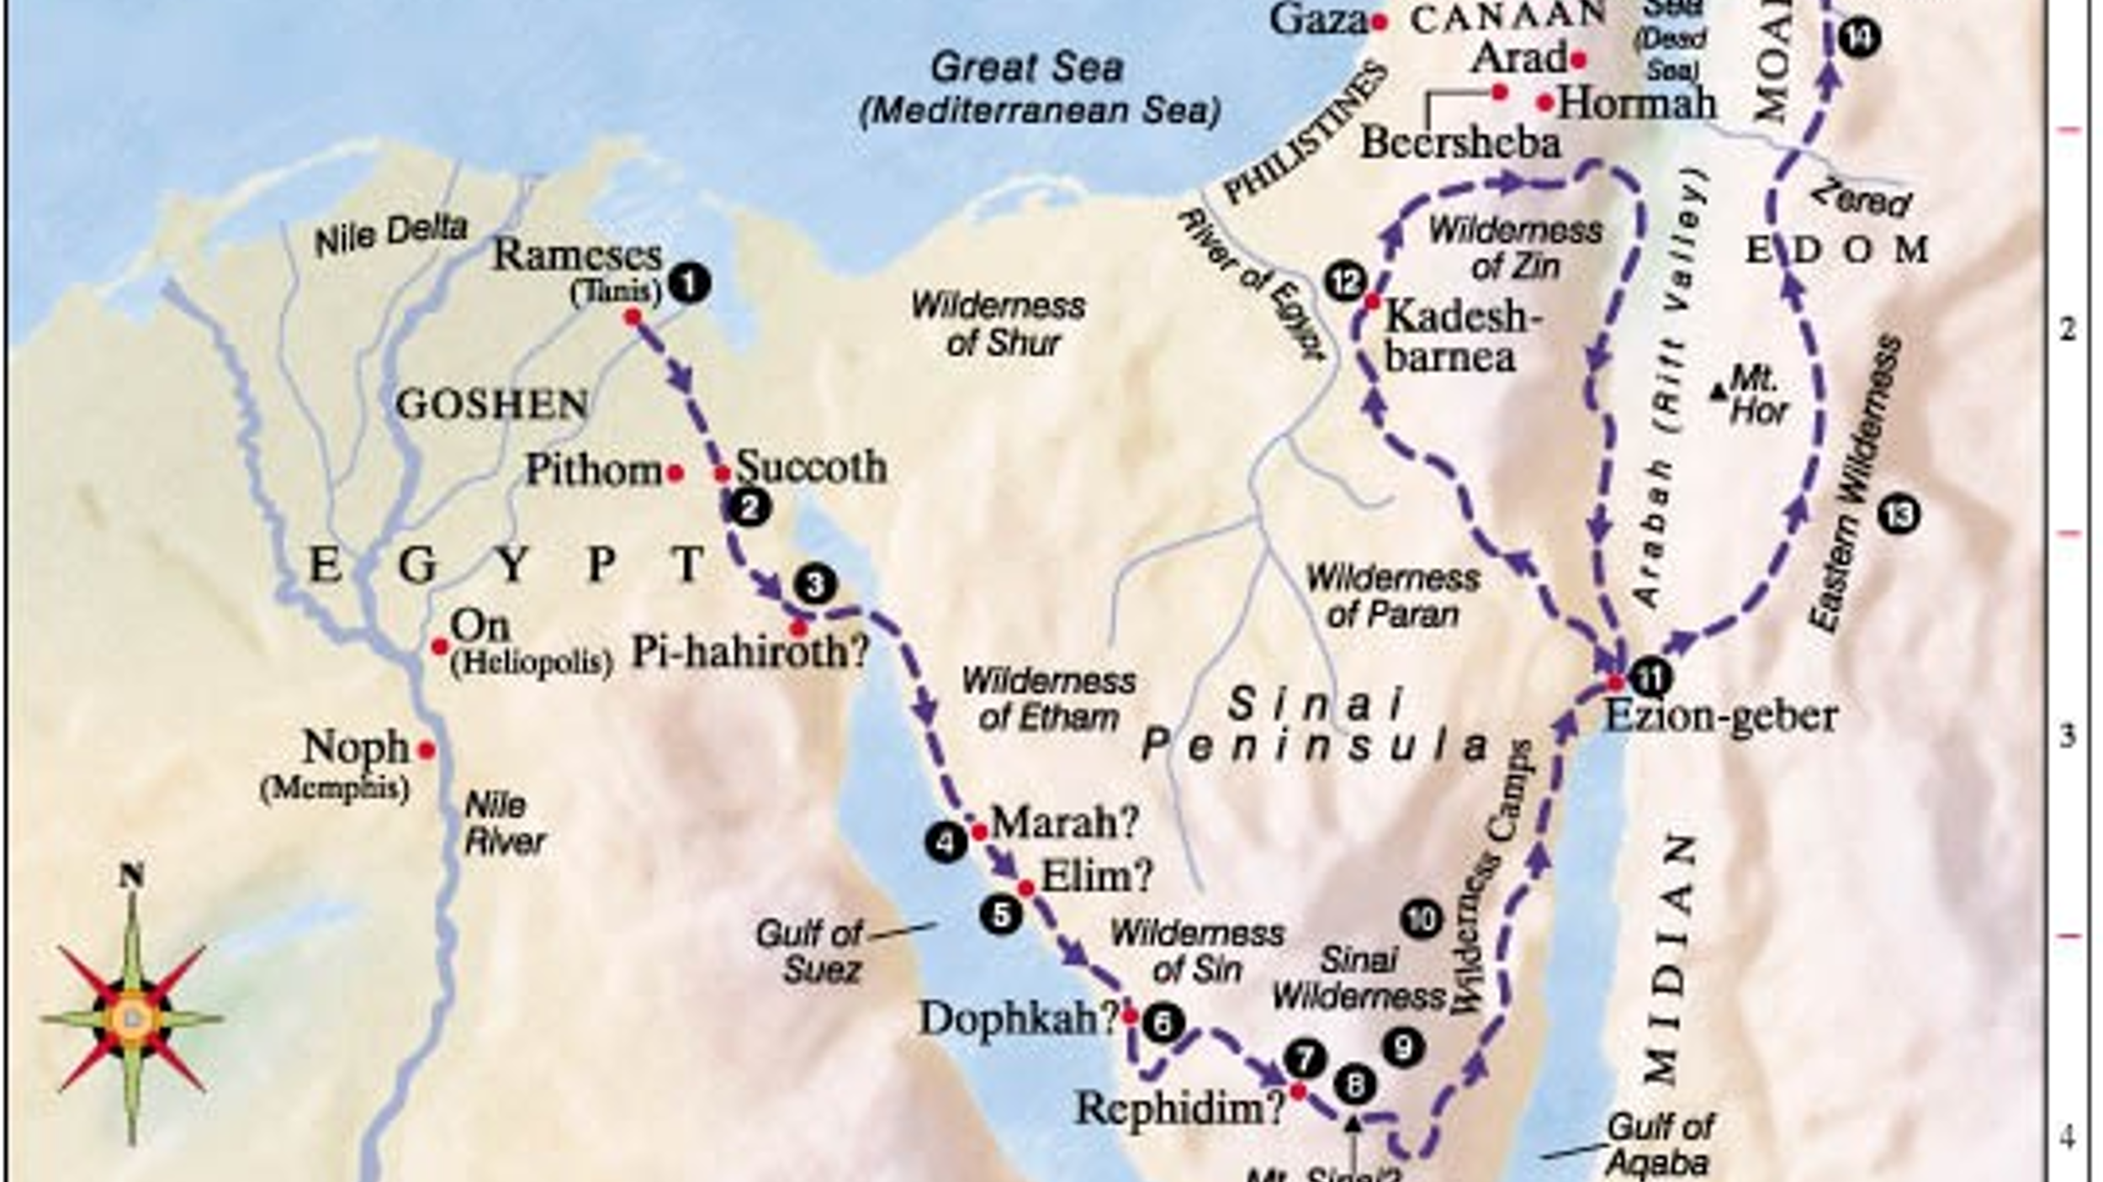

Notes

______________________________________________________

______________________________________________________

______________________________________________________

______________________________________________________

______________________________________________________
